Python

1. What is Python?
Python is a popular programming language. It is a widely used general-purpose, high-level programming language. It was created by Guido van Rossum and released in 1991.
It is used for:
- web development (server-side),
- software development,
- mathematics,
- system scripting.

Advantages :
- Presence of third-party modules
- Extensive support libraries(NumPy for numerical calculations, Pandas for data analytics etc)
- Open source and community development
- Versatile, Easy to read, learn and write
- User-friendly data structures
- High-level language
- Dynamically typed language(No need to mention data type based on the value assigned, it takes data type)
- Object-oriented language
- Portable and Interactive
- Ideal for prototypes – provide more functionality with less coding
- Highly Efficient
- (IoT)Internet of Things Opportunities
- Interpreted Language
- Portable across Operating systems

Applications :
- GUI based desktop applications
- Graphic design, image processing applications, Games, and Scientific/ computational Applications
- Web frameworks and applications
- Enterprise and Business applications
- Operating Systems
- Education
- Database Access
- Language Development
- Prototyping
- Software Development

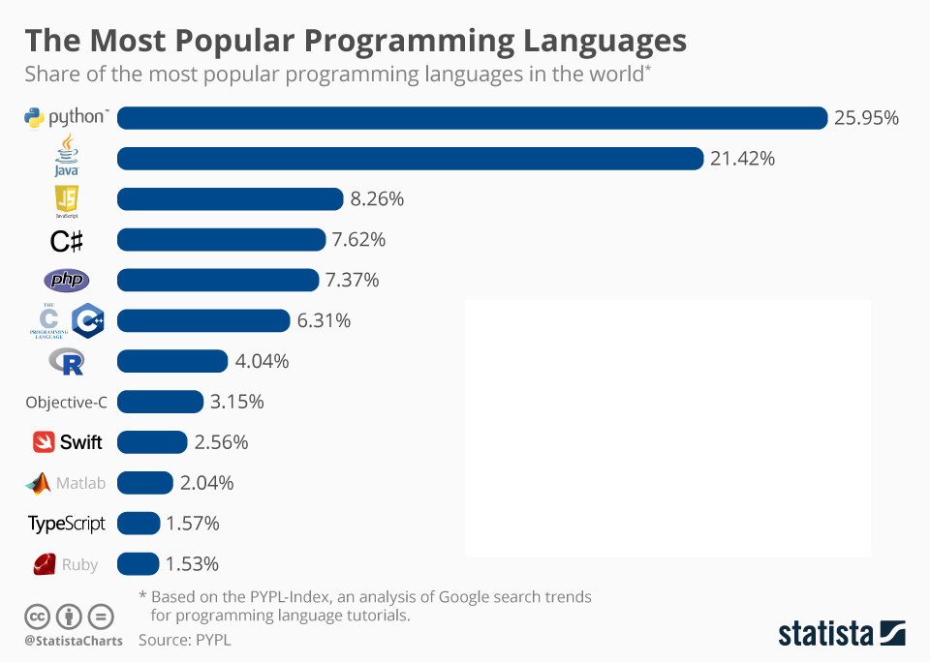

2. Why Python?
- Python works on different platforms (Windows, Mac, Linux, Raspberry Pi, etc).
- Python has a simple syntax similar to the English language.
- Python has syntax that allows developers to write programs with fewer lines than some other programming languages.
- Python runs on an interpreter system, meaning that code can be executed as soon as it is written. This means that prototyping can be very quick.
- Python can be treated in a procedural way, an object-oriented way or a functional way
Example 1:
print("Hello, World!")
Output:
Hello, World!

3. Installation of Python

Step 1: Select Version of Python to Install

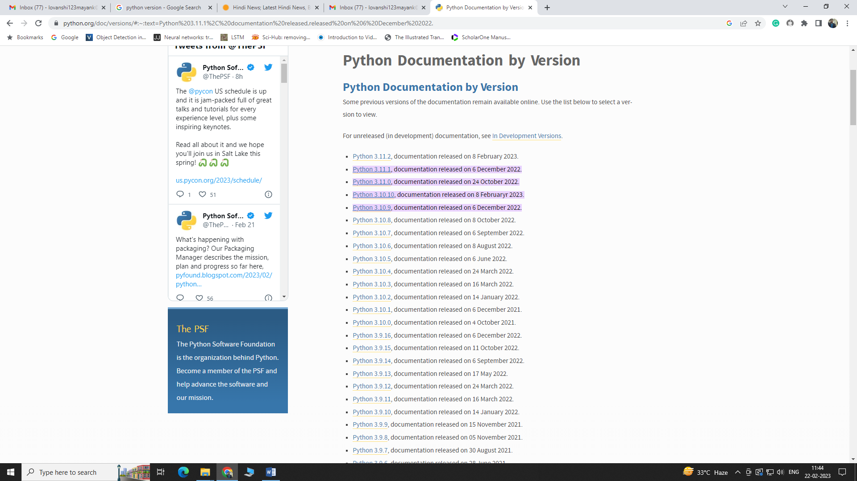

Step 2: Download Python Executable Installer

Step 3: Run Executable Installer

Step 4: Verify Python Was Installed On Windows/Linux

4. Python IDE:
- An IDE enables programmers to combine the different aspects of writing a computer program.
- IDEs increase programmer productivity by introducing features like editing source code, building executables, and debugging.
IDLE

IDLE (Integrated Development and Learning Environment) is a default editor that accompanies Python

This IDE is suitable for beginner level developers

The IDLE tool can be used on Mac OS, Windows, and Linux

Price: Free

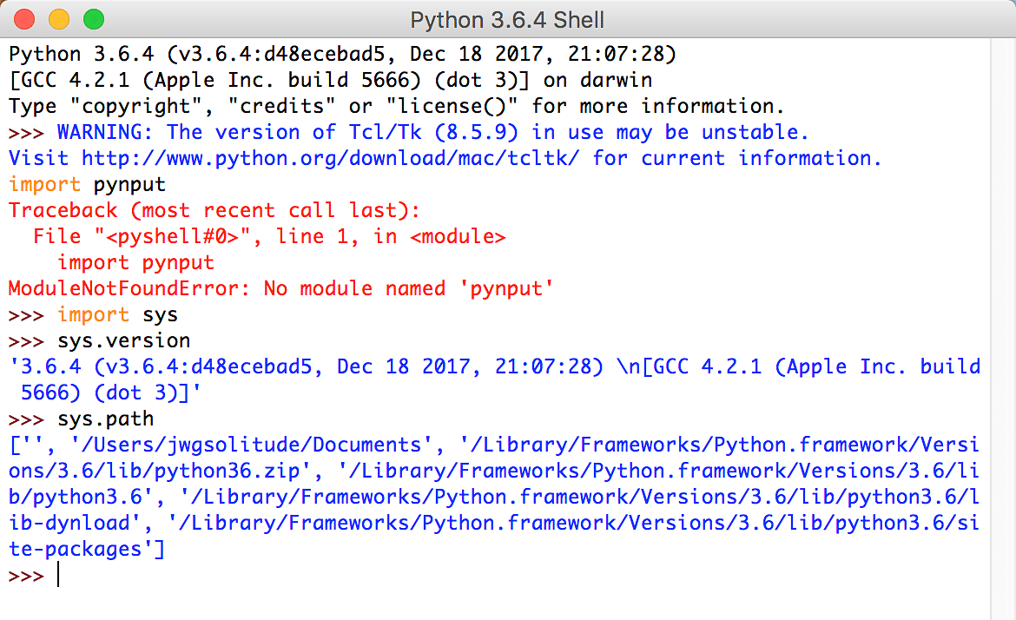

2. PyCharm

PyCharm is a widely used Python IDE created by JetBrains

This IDE is suitable for professional developers and facilitates the development of large Python projects

Price: Free
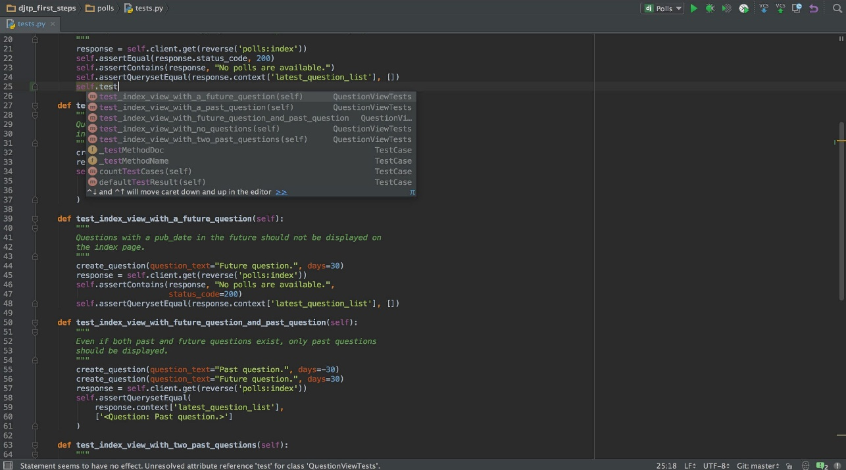
3. Visual Studio Code

Visual Studio Code is an open-source (and free) IDE created by Microsoft. It finds great use for Python development

VS Code is lightweight and comes with powerful features that only some of the paid IDEs offer

Price: Free

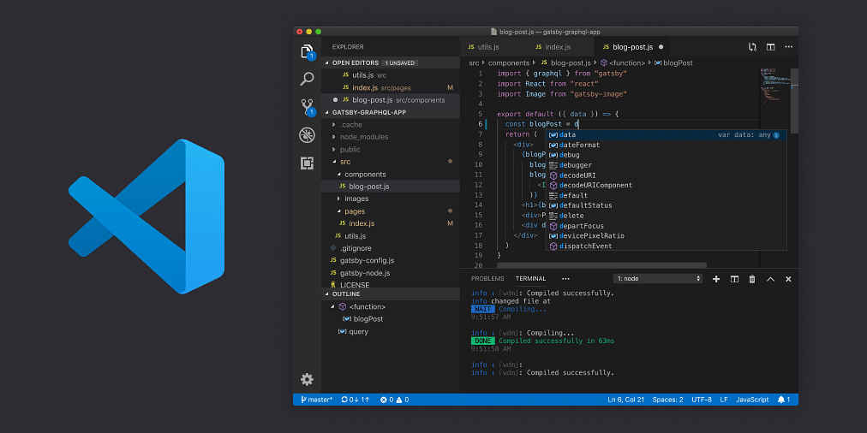

4. Jupyter

Jupyter is widely used in the field of data science

It is easy to use, interactive and allows live code sharing and visualization

Price: Free
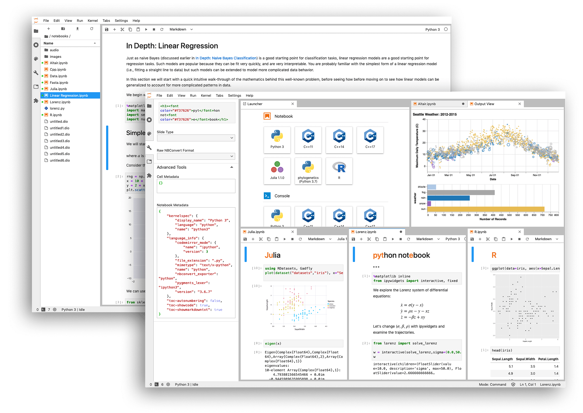

5. Spyder

Spyder is an open-source IDE most commonly used for scientific development

Spyder comes with Anaconda distribution, which is popular for data science and machine learning

Price: Free

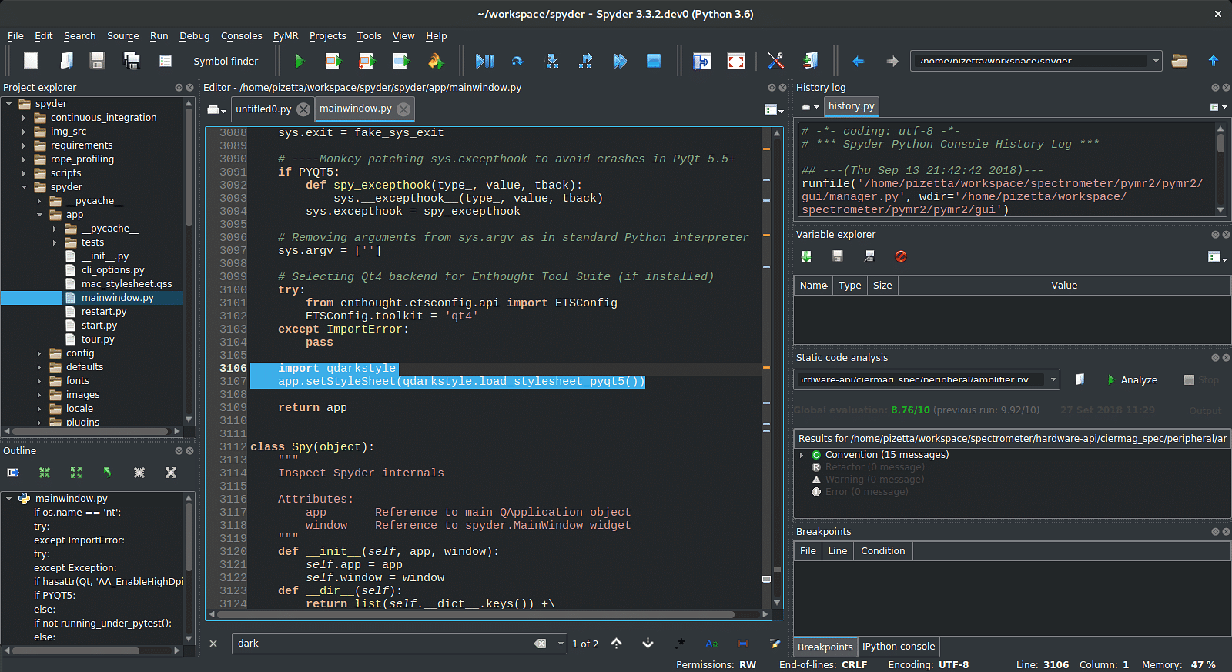

6. Google Colab:

Google Colab is a free Jupyter notebook that allows to run Python in the browser without the need for complex configuration.

It comes with Python installed and has all the main Python libraries installed.

It also comes integrated with free GPUs.
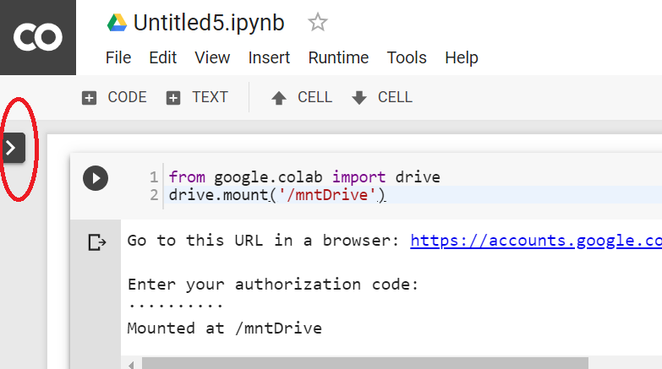

5. The Python Command Line
To test a short amount of code in python sometimes it is quickest and easiest not to write the code in a file. This is made possible because Python can be run as a command line itself.
Type the following on the Windows, Mac or Linux command line:
C:\Users\Your Name>python
Or, if the "python" command did not work, you can try "py":
C:\Users\Your Name>py
From there you can write any python, including our hello world example from earlier in the tutorial:
C:\Users\Your Name>python
Python 3.6.4 (v3.6.4:d48eceb, Dec 19 2017, 06:04:45) [MSC v.1900 32 bit (Intel)] on win32
Type "help", "copyright", "credits" or "license" for more information.
>>> print("Hello, World!")
Which will write "Hello, World!" in the command line:
C:\Users\Your Name>python
Python 3.6.4 (v3.6.4:d48eceb, Dec 19 2017, 06:04:45) [MSC v.1900 32 bit (Intel)] on win32
Type "help", "copyright", "credits" or "license" for more information.
>>> print("Hello, World!")
Hello, World!
Whenever you are done in the python command line, you can simply type the following to quit the python command line interface:
exit()

6. Python Indentation
- Indentation refers to the spaces at the beginning of a code line.
- Where in other programming languages the indentation in code is for readability only, the indentation in Python is very important.
- Python uses indentation to indicate a block of code.
Example:
No Error
if 5 > 2:
print("Five is greater than two!")
Error
if 5 > 2:
print("Five is greater than two!")
The number of spaces is up to you as a programmer, but it has to be at least one.
if 5 > 2:
print("Five is greater than two!")
if 5 > 2:
print("Five is greater than two!")
You have to use the same number of spaces in the same block of code, otherwise Python will give you an error:
if 5 > 2:
print("Five is greater than two!")
print("Five is greater than two!")

7. Python Variables
In Python, variables are created when you assign a value to it.

Rules for creating variables in Python
- A variable name must start with a letter or the underscore character.
- A variable name cannot start with a number.
- A variable name can only contain alpha-numeric characters and underscores (A-z, 0-9, and _ ).
- Variable names are case-sensitive (name, Name and NAME are three different variables).
- The reserved words(keywords) cannot be used naming the variable.

Example:
Variables in Python:
x = 5
y = "Hello, World!"

8. Comments
- Python has commenting capability for the purpose of in-code documentation.
- Comments start with a #, and Python will render the rest of the line as a comment:
Examples:
#This is a comment.
print("Hello, World!")

Multiple line comment starts from ‘’’ end with ‘’’
‘’’This is comment
print(“hello”)‘’’

9. Type Casting
Type Casting is the method to convert the variable data type into a certain data type in order to the operation required to be performed by users.
Example:
x = str(3) # x will be '3'
y = int(3) # y will be 3
z = float(3) # z will be 3.0
You can get the data type of a variable with the type() function.
x = 5
y = "John"
print(type(x)) # int
print(type(y)) # str

a. Type Casting int to float:
# Python program to demonstrate
# type Casting
# int variable
a = 5
# typecast to float
n = float(a)
print(n)
print(type(n))

b. Type Casting float to int:
# Python program to demonstrate
# type Casting
# int variable
a = 5.9
# typecast to int
n = int(a)
print(n)
print(type(n))

c. Type casting int to string:
# Python program to demonstrate
# type Casting
# int variable
a = 5
# typecast to str
n = str(a)
print(n)
print(type(n))

d. Type Casting string to int:
# Python program to demonstrate
# type Casting
# string variable
a = "5"
# typecast to int
n = int(a)
print(n)
print(type(n))

10. Python Data Types

Built-in Data Types
- In programming, data type is an important concept.
- Variables can store data of different types, and different types can do different things.
- Python has the following data types built-in by default, in these categories:
Text Type: | str
Numeric Types: | int, float, complex
Sequence Types: | list, tuple, range
Mapping Type: | dict
Set Types: | set, frozenset
Boolean Type: | bool
Binary Types: | bytes, bytearray, memoryview

a. Int
Int, or integer, is a whole number, positive or negative, without decimals, of unlimited length.
x = 1
y = 35656222554887711
z = -3255522
print(type(x))
print(type(y))
print(type(z))

b. Float
Float, or "floating point number" is a number, positive or negative, containing one or more decimals.
x = 1.10
y = 1.0
z = -35.59
print(type(x))
print(type(y))
print(type(z))
Float can also be scientific numbers with an "e" to indicate the power of 10.
x = 35e3
y = 12E4
z = -87.7e100
print(type(x))
print(type(y))
print(type(z))

c. Complex
Complex numbers are written with a "j" as the imaginary part:
x = 3+5j
y = 5j
z = -5j
print(type(x))
print(type(y))
print(type(z))

d. Type Conversion
You can convert from one type to another with the int(), float(), and complex() methods:
x = 1 # int
y = 2.8 # float
z = 1j # complex
#convert from int to float:
a = float(x)
#convert from float to int:
b = int(y)
#convert from int to complex:
c = complex(x)
print(a)
print(b)
print(c)
print(type(a))
print(type(b))
print(type(c))

e. Random Number
Python does not have a random() function to make a random number, but Python has a built-in module called random that can be used to make random numbers:
import random
print(random.randrange(1, 10))

f. Strings
Strings in python are surrounded by either single quotation marks, or double quotation marks.
'hello' is the same as "hello".
print("Hello") // Hello
print('Hello') // Hello

Assign String to a Variable
Assigning a string to a variable is done with the variable name followed by an equal sign and the string:
a = "Hello"
print(a)

Multiline Strings
You can assign a multiline string to a variable by using three quotes:
a = """Lorem ipsum dolor sit amet,
consectetur adipiscing elit,
sed do eiusmod tempor incididunt
ut labore et dolore magna aliqua."""
print(a)
or
a = '''Lorem ipsum dolor sit amet,
consectetur adipiscing elit,
sed do eiusmod tempor incididunt
ut labore et dolore magna aliqua.'''
print(a)

String Exercise
  - a = "Hello, World!"
print(a[1])

  - for x in "banana":
print(x)

  - a = "Hello, World!"
print(len(a))

  - txt = "The best things in life are free!"
print("free" in txt)

  - txt = "The best things in life are free!"
if "free" in txt:
print("Yes, 'free' is present.")

  - txt = "The best things in life are free!"
print("expensive" not in txt)

  - txt = "The best things in life are free!"
if "expensive" not in txt:
print("No, 'expensive' is NOT present.")

Slicing String
You can return a range of characters by using the slice syntax.
Specify the start index and the end index, separated by a colon, to return a part of the string.

    - b = "Hello, World!"
print(b[2:5])

    - b = "Hello, World!"
print(b[:5])

    - b = "Hello, World!"
print(b[2:])

    - b = "Hello, World!"
print(b[-5:-2])

Modify Strings
- a = "Hello, World!"
print(a.upper())
- a = "Hello, World!"
print(a.lower())
- a = " Hello, World! "
print(a.strip()) # returns "Hello, World!"
- a = "Hello, World!"
print(a.replace("H", "J"))
- a = "Hello, World!"
print(a.split(",")) # returns ['Hello', ' World!']

String Concatenation
- a = "Hello"
b = "World"
c = a + b
print(c)
- a = "Hello"
b = "World"
c = a + " " + b
print(c)

String Format
Following methods put error.

age = 36
txt = "My name is John, I am " + age
print(txt)

correct methods

age = 36
txt = "My name is John, and I am {}"
print(txt.format(age))

quantity = 3
itemno = 567
price = 49.95
myorder = "I want {} pieces of item {} for {} dollars."
print(myorder.format(quantity, itemno, price))

quantity = 3
itemno = 567
price = 49.95
myorder = "I want to pay {2} dollars for {0} pieces of item {1}."
print(myorder.format(quantity, itemno, price))

Escape Characters
To insert characters that are illegal in a string, use an escape character.
An escape character is a backslash \ followed by the character you want to insert.
Error:
txt = "We are the so-called "Vikings" from the north."
Correct Way:
txt = "We are the so-called \"Vikings\" from the north."

\' | Single Quote
\\ | Backslash
\n | New Line
\r | Carriage Return
\t | Tab
\b | Backspace
\f | Form Feed
\ooo | Octal value
\xhh | Hex value

String Methods
Method | Description
capitalize() | Converts the first character to upper case
casefold() | Converts string into lower case
center() | Returns a centered string
count() | Returns the number of times a specified value occurs in a string
encode() | Returns an encoded version of the string
endswith() | Returns true if the string ends with the specified value
expandtabs() | Sets the tab size of the string
find() | Searches the string for a specified value and returns the position of where it was found
format() | Formats specified values in a string
format_map() | Formats specified values in a string
index() | Searches the string for a specified value and returns the position of where it was found
isalnum() | Returns True if all characters in the string are alphanumeric
isalpha() | Returns True if all characters in the string are in the alphabet
isdecimal() | Returns True if all characters in the string are decimals
isdigit() | Returns True if all characters in the string are digits
isidentifier() | Returns True if the string is an identifier
islower() | Returns True if all characters in the string are lower case
isnumeric() | Returns True if all characters in the string are numeric
isprintable() | Returns True if all characters in the string are printable
isspace() | Returns True if all characters in the string are whitespaces
istitle() | Returns True if the string follows the rules of a title
isupper() | Returns True if all characters in the string are upper case
join() | Joins the elements of an iterable to the end of the string
ljust() | Returns a left justified version of the string
lower() | Converts a string into lower case
lstrip() | Returns a left trim version of the string
maketrans() | Returns a translation table to be used in translations
partition() | Returns a tuple where the string is parted into three parts
replace() | Returns a string where a specified value is replaced with a specified value
rfind() | Searches the string for a specified value and returns the last position of where it was found
rindex() | Searches the string for a specified value and returns the last position of where it was found
rjust() | Returns a right justified version of the string
rpartition() | Returns a tuple where the string is parted into three parts
rsplit() | Splits the string at the specified separator, and returns a list
rstrip() | Returns a right trim version of the string
split() | Splits the string at the specified separator, and returns a list
splitlines() | Splits the string at line breaks and returns a list
startswith() | Returns true if the string starts with the specified value
strip() | Returns a trimmed version of the string
swapcase() | Swaps cases, lower case becomes upper case and vice versa
title() | Converts the first character of each word to upper case
translate() | Returns a translated string
upper() | Converts a string into upper case
zfill() | Fills the string with a specified number of 0 values at the beginning

11. Operators

Operators are used to perform operations on variables and values.

Python divides the operators in the following groups:
- Arithmetic operators
- Assignment operators
- Comparison operators
- Logical operators
- Identity operators
- Membership operators
- Bitwise operators
Arithmetic operators
Arithmetic operators are used with numeric values to perform common mathematical operations:

+ | Addition | x + y
- | Subtraction | x - y
* | Multiplication | x * y
/ | Division | x / y
% | Modulus | x % y
** | Exponentiation | x ** y
// | Floor division | x // y

Assignment Operators:
Assignment operators are used to assign values to variables.

= | x = 5 | x = 5
+= | x += 3 | x = x + 3
-= | x -= 3 | x = x - 3
*= | x *= 3 | x = x * 3
/= | x /= 3 | x = x / 3
%= | x %= 3 | x = x % 3
//= | x //= 3 | x = x // 3
**= | x **= 3 | x = x ** 3
&= | x &= 3 | x = x & 3
|= | x |= 3 | x = x | 3
^= | x ^= 3 | x = x ^ 3
>>= | x >>= 3 | x = x >> 3
<<= | x <<= 3 | x = x << 3

Comparison Operators:
Comparison operators are used to compare two values.
== | Equal | x == y
!= | Not equal | x != y
> | Greater than | x > y
< | Less than | x < y
>= | Greater than or equal to | x >= y
<= | Less than or equal to | x <= y

Logical Operators:
Logical operators are used to combine conditional statements:

and | Returns True if both statements are true | x < 5 and x < 10
or | Returns True if one of the statements is true | x < 5 or x < 4
not | Reverse the result, returns False if the result is true | not(x < 5 and x < 10)

Identity Operators
Identity operators are used to compare the objects, not if they are equal, but if they are actually the same object, with the same memory location:

is | Returns True if both variables are the same object | x is y
is not | Returns True if both variables are not the same object | x is not y

Membership Operators
Membership operators are used to test if a sequence is presented in an object:
in | Returns True if a sequence with the specified value is present in the object | x in y
not in | Returns True if a sequence with the specified value is not present in the object | x not in y

Bitwise Operators
Bitwise operators are used to compare (binary) numbers:
& | AND | Sets each bit to 1 if both bits are 1
| | OR | Sets each bit to 1 if one of two bits is 1
^ | XOR | Sets each bit to 1 if only one of two bits is 1
~ | NOT | Inverts all the bits
<< | Zero fill left shift | Shift left by pushing zeros in from the right and let the leftmost bits fall off
>> | Signed right shift | Shift right by pushing copies of the leftmost bit in from the left, and let the rightmost bits fall off

12. Python Collections
There are four collection data types in the Python programming language:
List
- List is a collection which is ordered and changeable. Allows duplicate members.
- Lists are used to store multiple items in a single variable.
- Lists are one of 4 built-in data types in Python used to store collections of data, the other 3 are Tuple, Set, and Dictionary, all with different qualities and usage.
- List items are indexed, the first item has index [0], the second item has index [1] etc.
- Lists are created using square brackets:

Example1:
thislist = ["apple", "banana", "cherry"]
print(thislist)
Output:
['apple', 'banana', 'cherry']
Example2:
thislist = ["apple", "banana", "cherry", "apple", "cherry"]
print(thislist)
Output:
['apple', 'banana', 'cherry', 'apple', 'cherry']

Tuple:
- Tuple is a collection which is ordered and unchangeable. Allows duplicate members.
- Tuples are used to store multiple items in a single variable.
- Tuple is one of 4 built-in data types in Python used to store collections of data, the other 3 are List, Set, and Dictionary, all with different qualities and usage.
- A tuple is a collection which is ordered and unchangeable.
- Tuples are written with round brackets.
Example1:
thistuple = ("apple", "banana", "cherry")
print(thistuple)
Output:
('apple', 'banana', 'cherry')

Example2:
thistuple = ("apple", "banana", "cherry", "apple", "cherry")
print(thistuple)
Output:
('apple', 'banana', 'cherry', 'apple', 'cherry')
Set:
- Set is a collection which is unordered and unindexed. No duplicate members.
- Sets are used to store multiple items in a single variable.
- Set is one of 4 built-in data types in Python used to store collections of data, the other 3 are List, Tuple, and Dictionary, all with different qualities and usage.
- A set is a collection which is unordered, unchangeable*, and unindexed.
- Sets are written with curly brackets.
Example 1:
thisset = {"apple", "banana", "cherry"}
print(thisset)
Output:
{'banana', 'apple', 'cherry'}

Example 2:
thisset = {"apple", "banana", "cherry", "apple"}
print(thisset)
Output:
{'banana', 'apple', 'cherry'}

Dictionary:
- Dictionaries are used to store data values in key:value pairs.
- A dictionary is a collection which is ordered*, changeable and do not allow duplicates.
- Dictionaries are written with curly brackets, and have keys and values.
- Dictionary is a collection which is ordered* and changeable. No duplicate members.
Example 1:
thisdict = {
"brand": "Ford",
"model": "Mustang",
"year": 1964
}
print(thisdict)
Output:
{'brand': 'Ford', 'model': 'Mustang', 'year': 1964}

Example 2:
thisdict = {
"brand": "Ford",
"model": "Mustang",
"year": 1964,
"year": 2020
}
print(thisdict)
Output:
{'brand': 'Ford', 'model': 'Mustang', 'year': 2020}

LIST | SET | TUPLE | DICTIONARY
Mutable | Immutable | Immutable | Mutable
Ordered | Unordered | Ordered | Unordered
Changeable | Unchangeable | Unchangeable | Changeable
Allow Duplicate | No Duplicate | Allow Duplicate | No Duplicate
Square Bracket | Curly Bracket | Round Bracket | Curly Bracket

